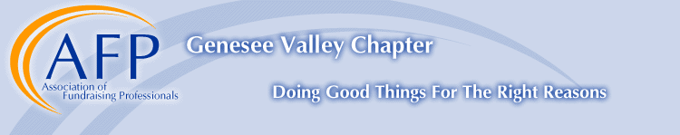

Williams Diversity Scholarship
Deadline for application: October 3, 2018 at noon
NO DEADLINE EXTENSIONS!

The purpose of the Williams Diversity Scholarship is to promote and enhance the professional development of fundraising professionals who are members of a diverse community or who are employed by grassroots organizations that are dedicated to serving diverse populations. The scholarship is designed to encourage diverse involvement and membership in the Genesee Valley Chapter of AFP.

The Williams Diversity Scholarship is funded by AFP Board member John Williams. Inspired by the support he received from AFPGV colleagues as he transitioned from a career in law to the field of fundraising, Mr. Williams launched the Williams Diversity Scholarship to offer that opportunity to others of diverse communities. Each year, one scholarship will be awarded, offering the recipient the opportunity to learn from experienced fundraising professionals and enhance their skills to better serve the Rochester community.

The Chapter will consider applications from fundraising professionals who meet the following criteria:
- Candidate is employed by a non-profit organization operating within the greater Rochester area served by the AFP Genesee Valley Chapter.
- Candidate is primarily responsible for fundraising within the nonprofit organization for which he/she is employed.
- Candidate is a member of a diverse community or is employed by a grassroots organization that primarily serves diverse communities.
- Demonstrate a financial need. Strong consideration will be given to individuals employed by organizations whose budgets are constrained.
- Willingness to serve on the AFPGV Diversity Committee during the awarded year, with the hope that this service will continue.
- Preference will be given to those who have never been a member of AFPGV.

Benefits of scholarship program are valid for ONE year and include the following:

- 100% of a one year membership to AFP (One scholarship will be awarded).
- Admission to a maximum of 4 AFPGV programs throughout the year. (Does not include AFP local or international conference.)
- Paid admission to the AFPGV National Philanthropy Day Awards Luncheon. Recipient will sit with the benefactor of the scholarship, John Williams.
- John Williams, retired fundraiser and lawyer, will provide fundraising and career mentorship throughout the year.

Williams Diversity Scholarship Application
Deadline for application: October 3, 2018 at noon
NO DEADLINE EXTENSIONS!

Applicant Name: _____________________________________________________________________

Job Title: ___________________________________________________________________________

Organization Name: __________________________________________________________________

Preferred Address: ___________________________________________________________________

City, State, Zip: ______________________________________________________________________

Business Phone: __________________________ Home/Cell Phone: ________________________

Williams Diversity Scholarship finalists may be contacted by a member of the scholarship committee for a brief phone conversation (10-15 minutes). Which number is the best number to reach you? (please circle)

Business Home Other: ____________________

E-mail address: _____________________________________________________________________

Number of years fundraising with current organization:
______ Years _____Months

Annual agency operating budget: $ ______________________________________________________

Have you ever been a member of AFP or attended any programs? □ Yes □ No

Are you a member of a diverse community or work for a grassroots organization that serves one?
(Please describe, please write no more than 100 words)

___________________________________________________________________________________
___________________________________________________________________________________
___________________________________________________________________________________
___________________________________________________________________________________

  
SIGNATURE: _____________________________________________________________

Questions, Completed Applications and Attachments to: Sami Sheehan, Individual Giving Manager, Lollypop Farm, the Humane Society of Greater Rochester, 99 Victor Road, Fairport, NY 14450; Phone: 585-223-1330 x195. If emailing application please send to ssheehan@lollypop.org AND info@afpgv.org

